FOR SALE

SELF CONTAINED BUILDING

WITH PARKING

Development Potential

Approx 2,100 sq ft
185A OXFORD ROAD
READING RG1 7UZ
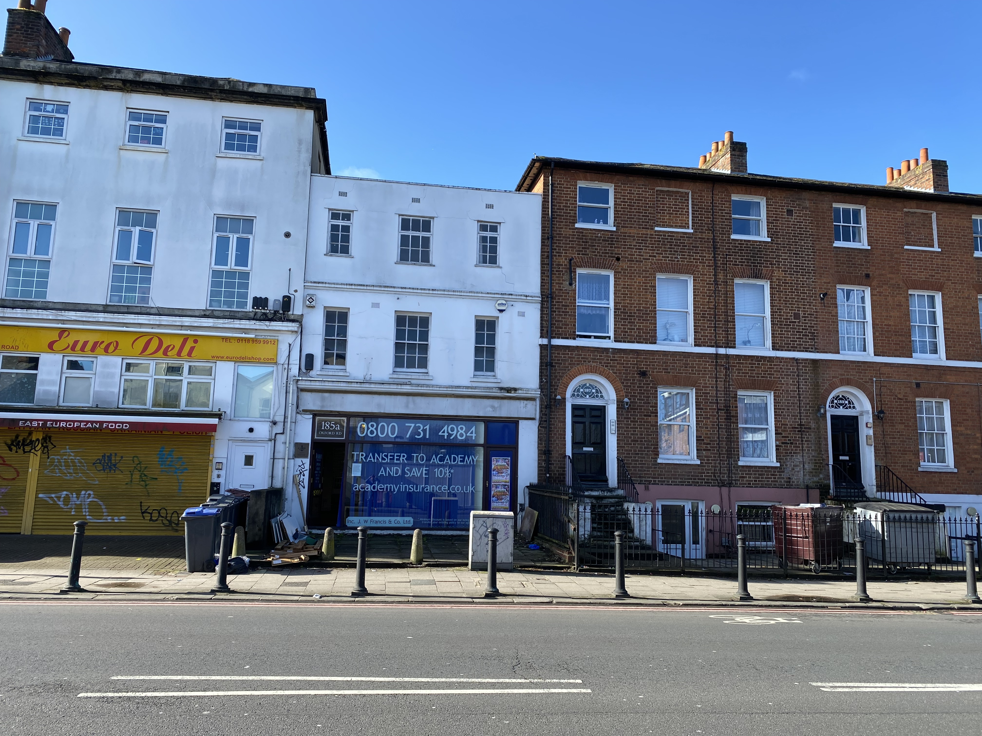

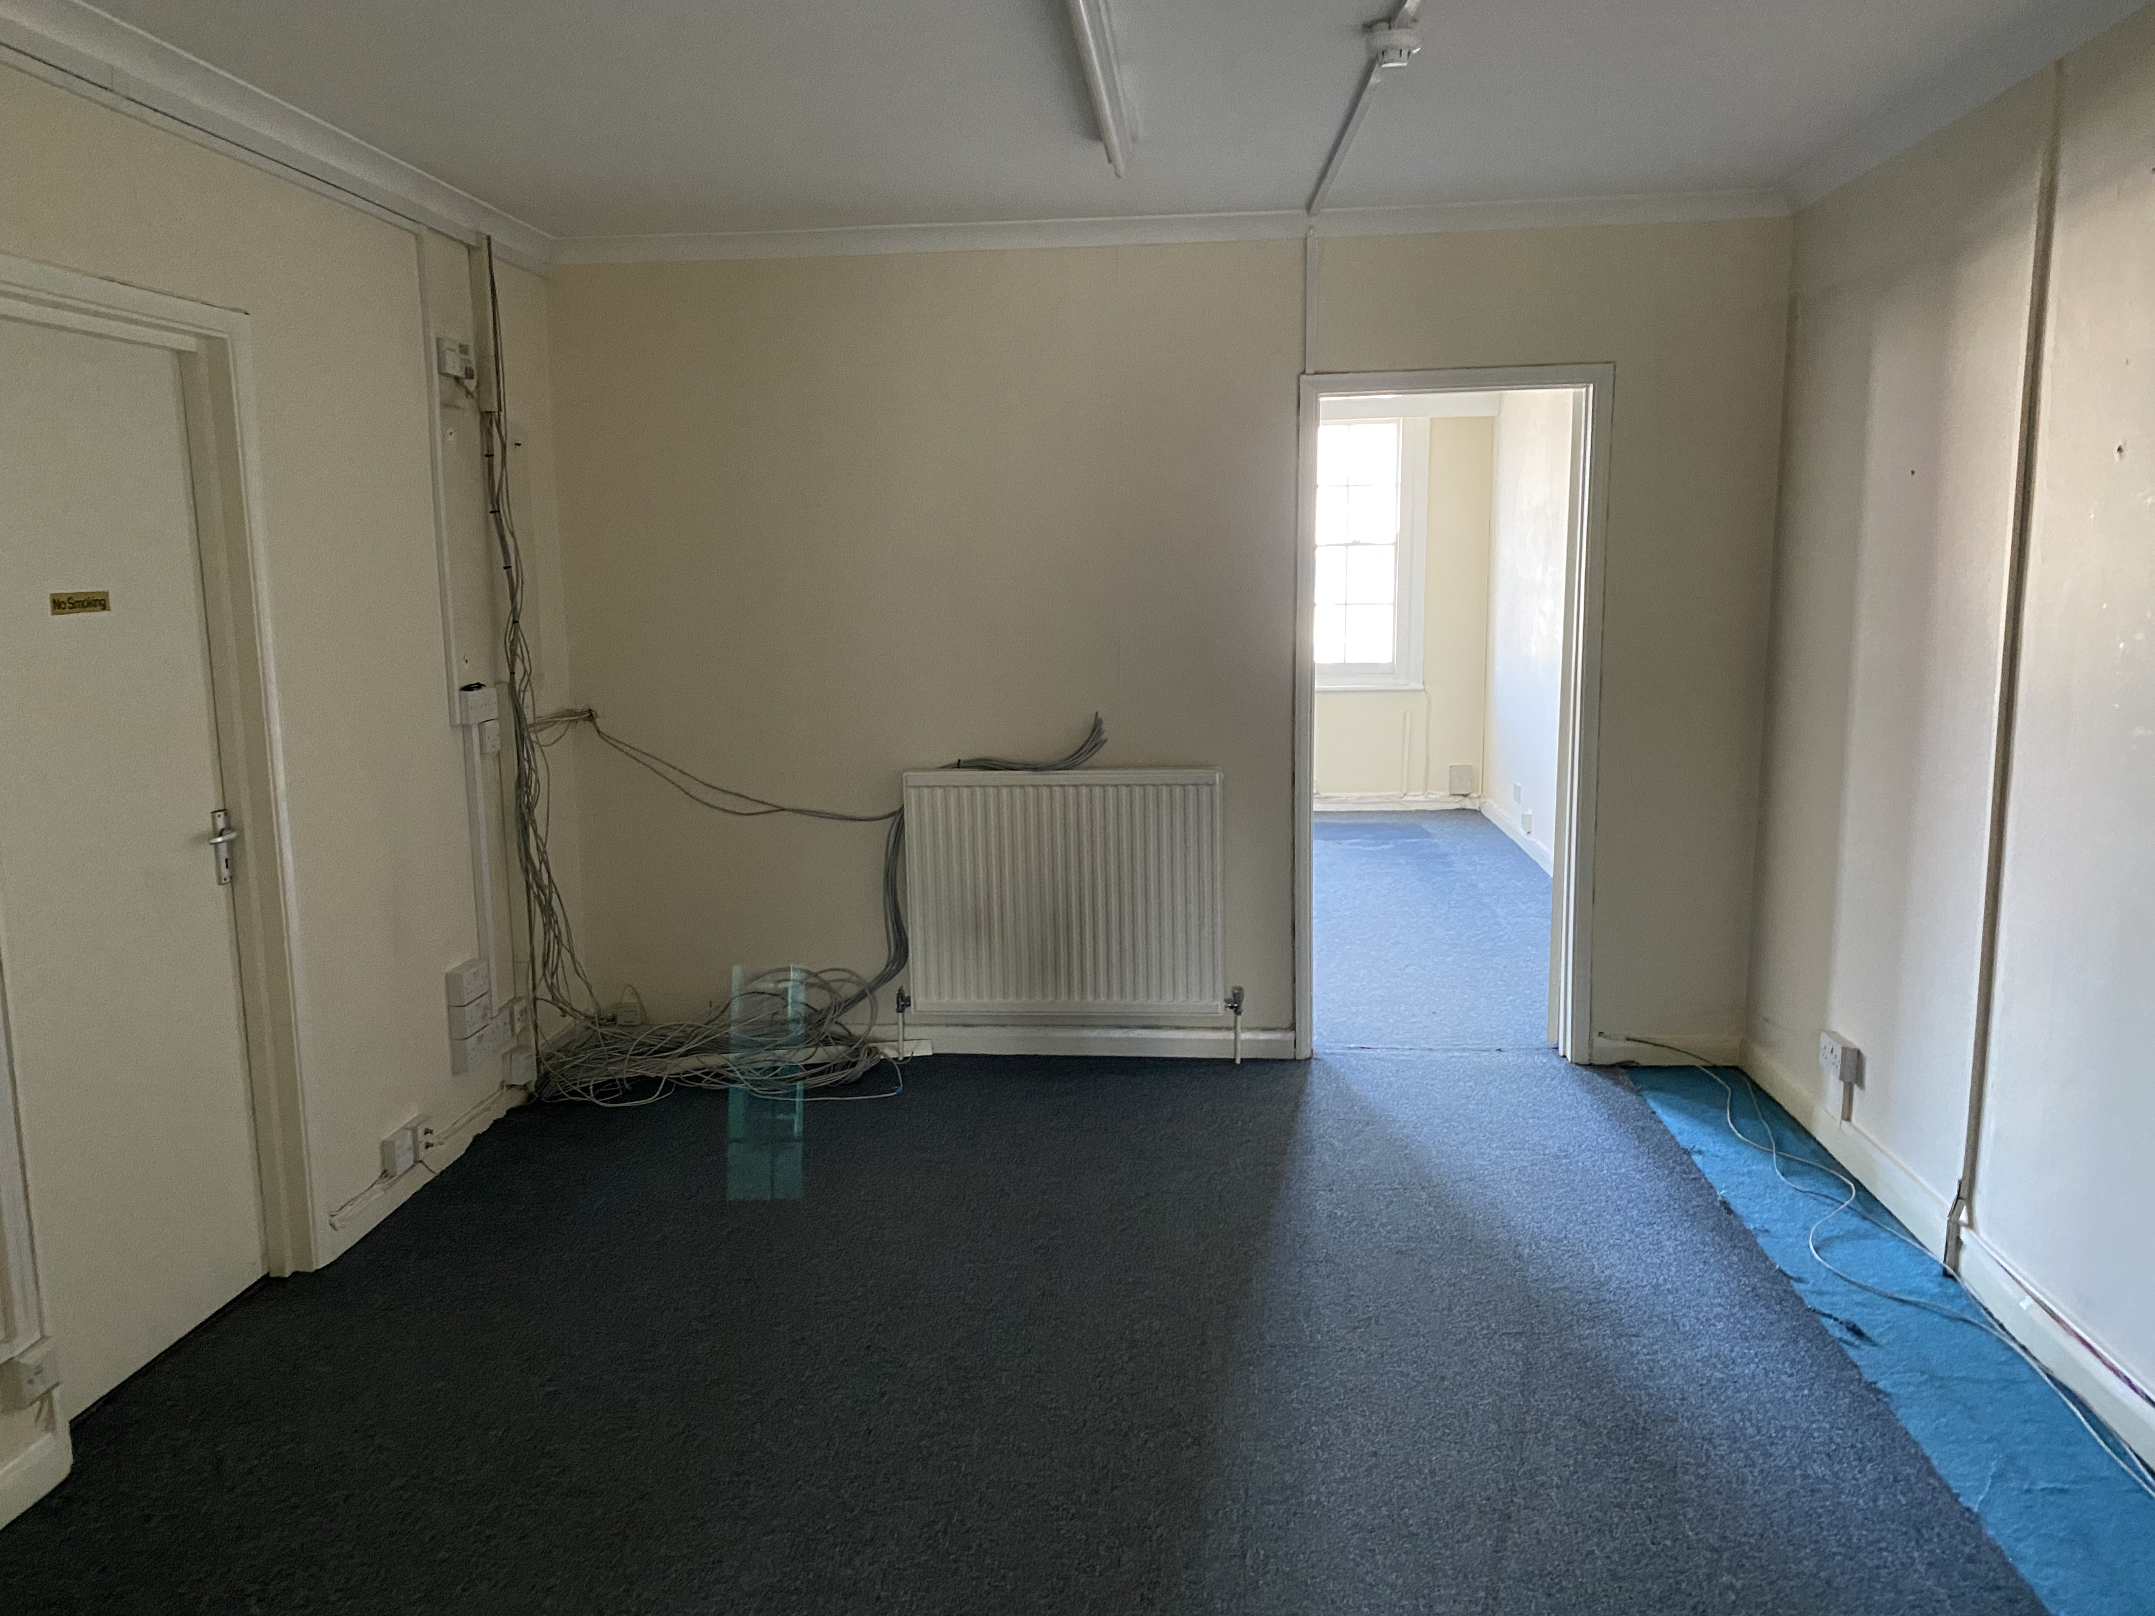

LOCATION
The property is located on the busy Oxford Road just a short walk from Reading Town Centre. Oxford road is the main route providing access to the west of Reading and benefits from a variety of retail and industrial units and provides access to the M4 motorway at junction 12.

DESCRIPTION
The property is a mid-terraced three storey building with car parking to the rear. The building provides an open plan layout on the ground floor with a mixture of open plan and partitioned areas at first floor level. On the second floor there is a self-contained flat benefitting from a separate entrance on the ground floor.

ACCOMMODATION
Ground floor 932 sq ft
First floor 825 sq ft
Second floor flat 396 sq ft
TOTAL 2,153 sq ft

AMENITIES
- Self-Contained Building
- Second floor flat
- 6 onsite parking spaces
- Rarely available

PRICE
£380,000

EPC
The building and flat have
a current rating of 80D

VAT
VAT will not be payable on the sale price

PROOF OF FUNDING
Prior to an offer being accepted and solicitors being instructed any prospective purchaser will have to provide full details of funding.

LEGAL COSTS
Each party is to bear their own
legal costs in this matter.

VIEWING
Strictly by appointment through
the sole agent Walters Commercial
Shaun Walters
M: 07764 230561
E: swalters@walterscommercial.co.uk

