FOR SALE
DEVELOPMENT SITE (stp)/OWNER OCCUPIER
APPROX 0.93 ACRES
Including various buildings comprising 15,454 sq ft
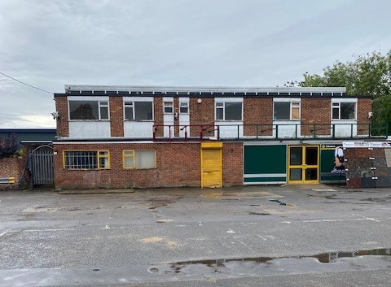
Woodley Green, Church Road
Woodley, Reading RG5 4QP

LOCATION
The property is located approximately 3 miles east of Reading Town Centre and within walking distance of the busy Woodley District centre where and excellent range of retail units, restaurants and public Houses can be found. There is excellent access onto Jct 10 of the M4 Motorway, which is approximately 5 minutes drive from the Site.
Building 1 (storage) 1617 sq ft 150.2 sq m
Building 2 (storage) 2260 sq ft 209.9 sq m
Former Plumbing/kitchen showroom
3616 sq ft 335.9 sq m
Main Building 6581 sq ft 611.3 sq m
Storage building 1380 sq ft 128.2 sq m
Total 15,454 sq ft 1435.5 sq m

The site is located in a predominantly residential area comprising mainly two storey town houses in the immediate vicinity with a mixture of semi-detached and detached houses nearby.
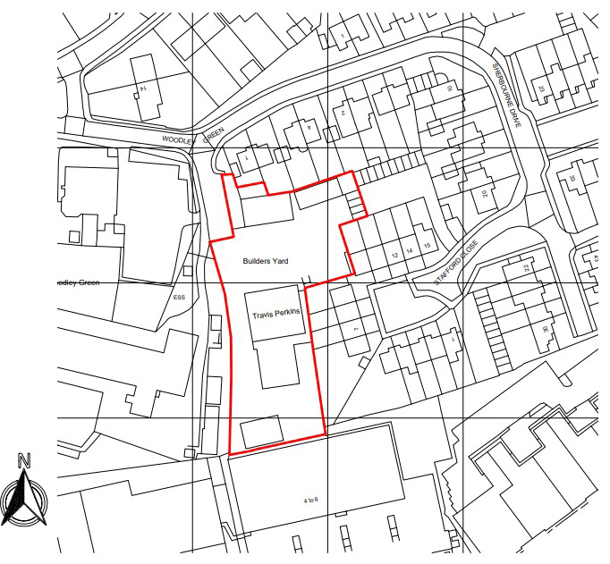

DESCRIPTION
The property comprises a site of approximately 0.93 acres with a number of two storey and single storey buildings arranged around the site. The buildings are generally in reasonable condition and if retained could be utilised for a variety of uses. The site currently has a single access shared with the adjoining occupier and has large double gates at the entrance providing security.

ACCOMMODATION

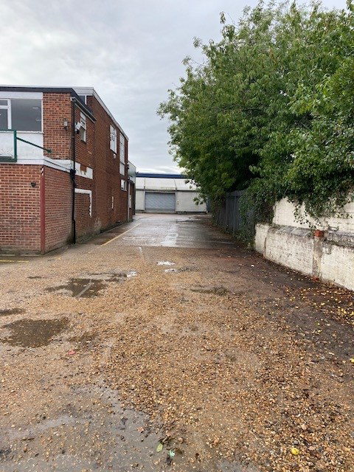

PLANNING
The property has been used for the last 35 years as a builders merchants for the sale of building and plumbing materials and associated uses such as the sale of kitchens and tools.
The site would be suitable for a redevelopment for residential units and interested parties will need to make their own enquiries with Wokingham District council.
The owners have not explored the possibility of redevelopment, nor undertaken any contamination reports.
Please note that the owners will not consider selling their interest to another builders merchants whose business will compete with their own and a covenant will be included to exclude this use.

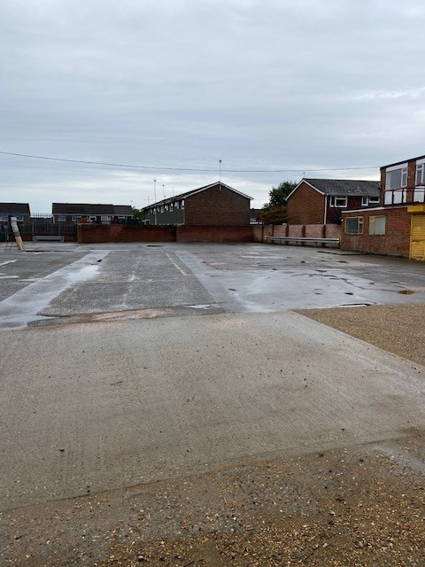

BUSINESS RATES
The property lies within the administrative authority of Wokingham District Council and the current rateable value for the site and buildings is £77500.
SERVICES
We understand that mains electricity, drainage, gas and water services are either connected to the site or available for connection in the vicinity. However, prospective purchasers are advised to make their own independent enquiries of the individual authorities to verify the capacity and availability of such services.

GUIDE PRICE
The Freeholders are seeking offers
in the region of £2 million pounds.

VAT
The property is elected for VAT therefore VAT will be payable on the purchase price.

METHOD OF SALE
The property’s freehold interest is being offered for sale by way of informal ,non binding tender with the vendor reserving the right not to accept the highest or any offer and also reserving the right to withdraw the property from sale or to vary the method of sale at any time without notice.

UNCONDITIONAL OFFERS
If an unconditional offer is accepted completion is to take place within four weeks of exchange of contracts with 10% payable on exchange and the full balance of the purchase price payable immediately upon completion of the sale.

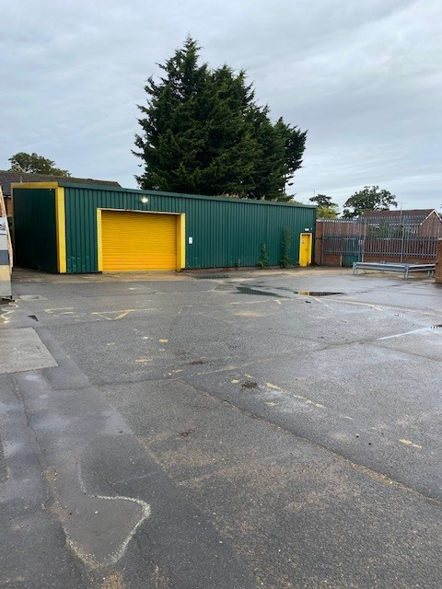

Conditional (subject to planning) Offers
All conditional (subject to planning) offers must be made net of anticipated S106 /CIL costs and any anticipated abnormal costs associated with the development of the site. Any anticipated abnormal costs should be clearly quantified in the offer letters.
If a conditional offer is accepted a 10% deposit will be payable upon exchange of contracts with completion to take place within eight weeks of the grant of planning permission with the full balance of the purchase price payable immediately upon completion of the sale.
All conditional offers should include at least:
- Full details of the purchaser’s proposed development scheme including the number ,type and mix of units, together with an indicative layout plan.
- The purchaser’s Community Infrastructure Levy (CIL) calculation.
- The purchaser’s affordable housing provision.
- The purchaser’s proposed timetable and strategy for achieving planning permission.
All offers should state whether they are submitted with or without Board approval and whether they are dependant on Bank or similar finance being available with confirmation or proof of funding.
Written offers for the property are invited by 12 noon on Wednesday January 19th 2022.
All offers should be marked “Woodley Green Site – Offer to Purchase” and addressed to Mr Shaun Walters, Parkinson Holt LLP,Holybrook House,
63 Castle Street, Reading RG1 7SN or swalters@walterscommercial.co.uk

FURTHER INFORMATION
AVAILABLE UPON REQUEST
- Energy Performance Certificates
for the main buildings
- An asbestos Audit
- Title Plans for the site

VIEWING
Strictly by appointment through
the sole agent Walters Commercial
Shaun Walters
M: 07764 230561
E: swalters@walterscommercial.co.uk

