TO LET

Ground Floor Business Unit

Approx 733 sq ft

plus 431 sq ft reduced height storage
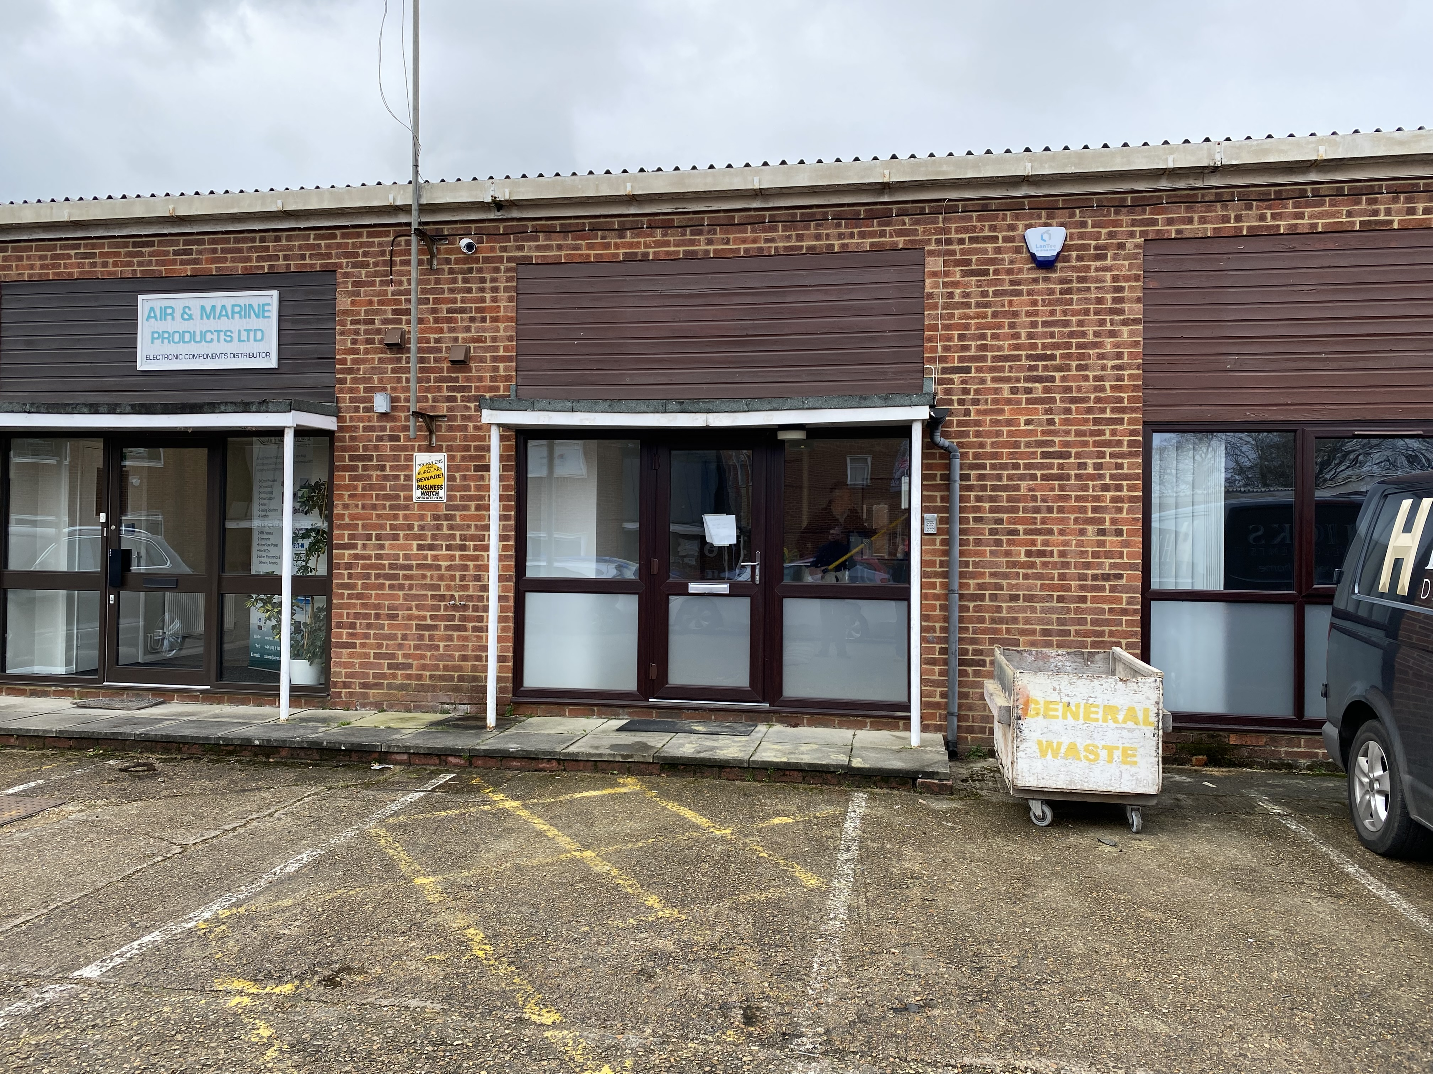
Unit 4 Parkside Business Park
Woodley nr Reading RG5 4JB

DESCRIPTION
Unit 4 consists of a mid-terrace
self-contained single storey property providing good quality offices with the added benefit of reduced height storage at first floor level.

LOCATION
Woodley is a thriving town located approximately 3 miles east of Reading with excellent access to the A329/M4 motorway. Parkside business Park is conveniently located opposite Woodley shopping centre which provides local amenities including a Waitrose, several restaurants and a variety of shops.

ACCOMMODATION
Ground Floor 733 sq ft 68 sq m
1st floor 431 sq ft 40 sq m (Reduced height)

AMENITIES
- Redecorated throughout
- New carpet
- Kitchen
- 3 on site parking spaces

LEASE
A new full repairing and insuring lease is to be granted for a term to be agreed.

RENT
£20,000 per annum payable quarterly in advance.

VAT
TBC

SERVICE CHARGE
A service charge is payable to cover
the maintenance of the car park and landscaping and general security duties. The current cost for unit 4 is £919 per annum.

BUILDING INSURANCE
The current building insurance
annual premium is £145.24p.

LEGAL COSTS
Each party is to bear their own
legal costs in this matter.

VIEWING
Strictly by appointment through
the sole agent Walters Commercial
Shaun Walters
M: 07764 230561
E: swalters@walterscommercial.co.uk

