TO LET

FIRST FLOOR OFFICE SUITE

APPROX. 2876 SQ FT (267.2 SQ M)
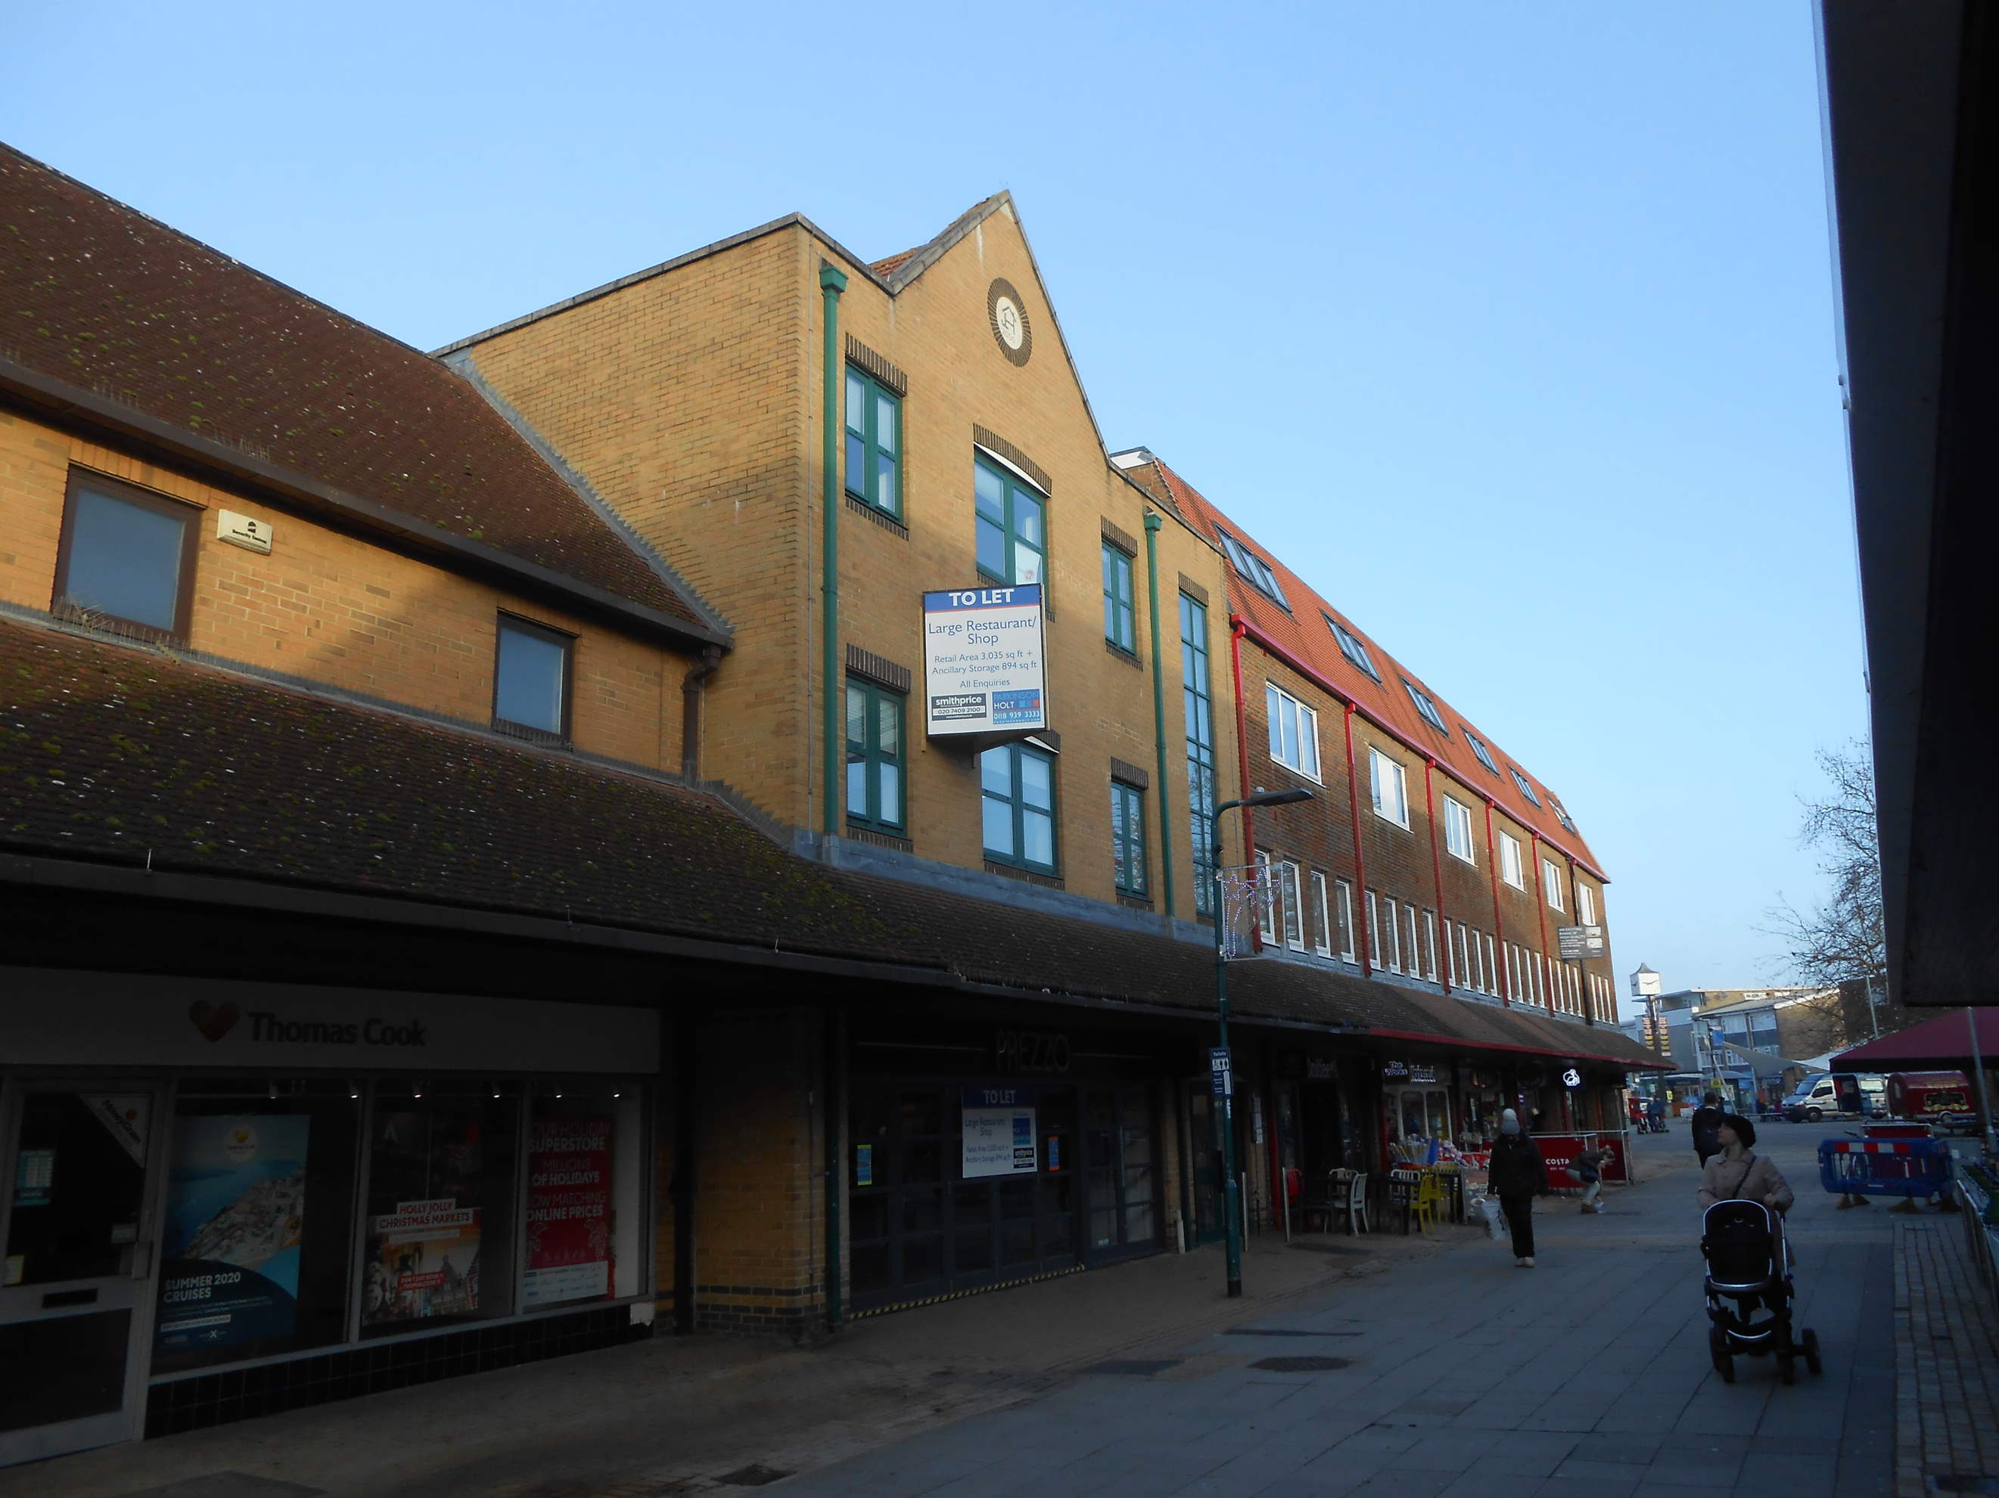

61-63 CROCKHAMWELL ROAD
WOODLEY, READING RG5 3JP

LOCATION
Woodley is a thriving town with excellent access onto the A329 / M4 motorway. The entrance to the suite is opposite Waitrose and Woodley also benefits from a Lidl and a variety of retailers.

DESCRIPTION
The property comprises a first floor office suite which is in excellent condition throughout comprising predominantly open plan space with one individual office. Also there is a small kitchen area and male and female WCs. In addition, there are 7 car parking spaces to the rear with a possibility of further spaces available off site.

ACCOMMODATION
1st floor 2876 sq ft 267.2 sq m

AMENITIES
- Predominantly open plan space
- Suspended ceilings with recessed lighting
- Male and female wc’s
- Carpeting
- Perimeter trunking
- Natural light to front and rear

TERMS
The office is available on a new effective full repairing and insuring lease for a term to be agreed.

RENT
£15 per sq ft

VAT
VAT is payable on the rent
and service charge.

SERVICE CHARGE
A service charge will be payable to cover the cost of the external maintenance of the building. Approximate current cost is £1160 plus VAT.

BUILDING INSURANCE
The current annual proportion of building insurance for this floor is £476.

BUSINESS RATES
Description in the list is offices and premises. Rateable value; £42,500 as indicated on the VOA website

LEGAL COSTS
Each party is to bear their own legal costs in this matter.

VIEWING
Strictly by appointment through
the sole agent Walters Commercial
Shaun Walters
M: 07764 230561
E: swalters@walterscommercial.co.uk

