TO LET

OFFICE SUITES

405/351/756 SQ FT
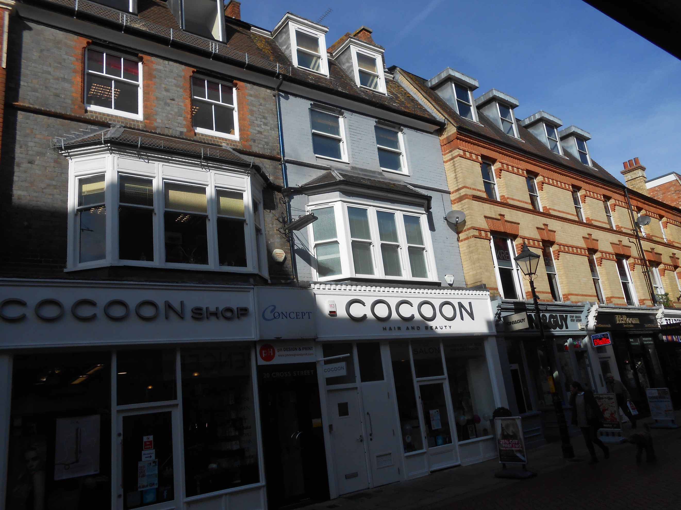

2ND AND 3RD FLOORS
20 CROSS STREET, READING RG1 1SN

LOCATION
The property occupies an excellent town centre location in Cross Street surrounded by retail and leisure users. Reading rail station is within a 5 minute walk and provides an excellent service to London Paddington, Waterloo and the west country.

DESCRIPTION
The property provides two self contained office suites on the upper floors with access via a separate ground floor entrance. The offices could be let separately or together and offer suspended ceilings, lighting ,carpeting and heating/air conditioning. There are shared kitchen and toilet facilities.

ACCOMMODATION
2nd floor 405 sq ft 37.6 sq m
3rd floor 351 sq ft 32.6 sq m
TOTAL 756 sq ft 70.2 sq m

AMENITIES
- Suspended ceiling
- Recessed lighting
- Carpeting
- Heating/Air conditioning

LEASE
The property is available on the basis of a new effective full repairing and insuring lease via the service charge for a term to be agreed.

RENT
Second Floor £6500 per annum exclusive
Third Floor £5500 per annum exclusive

VAT
All prices quoted are exclusive of VAT

SERVICE CHARGE
A service charge will be payable on each floor to cover the cost on security, fire maintenance, alarm system, general external repairs, cleaning of common parts and building insurance.

BUILDING INSURANCE
The Landlord will insure the building and recoup the premium from the tenants.

LEGAL COSTS
Each party to be responsible for their own proper legal costs. However should any party withdraw from this matter following solicitors being instructed then the landlords abortive legal costs will become payable.

VIEWING
Strictly by appointment through
the sole agent Walters Commercial
Shaun Walters
M: 07764 230561
E: swalters@walterscommercial.co.uk

