# TO LET

# SELF CONTAINED OFFICE SUITE

# CLOSE TO READING RAIL STATION

# APPROX 837 SQ FT

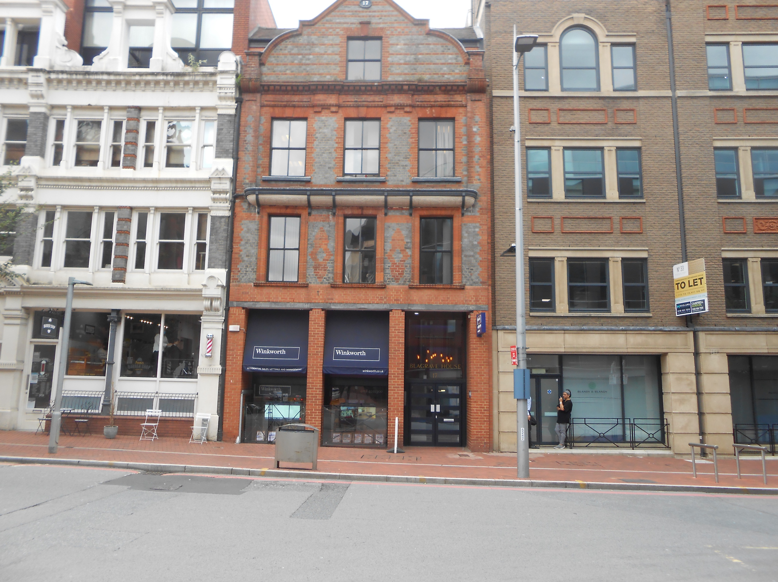

# Third Floor, Blagrave House, 17 Blagrave Street, READING RG1 1QB

## LOCATION

Blagrave House is conveniently situated at the heart of Reading,s business community and is a short walk from Reading Rail Station, the Heathrow Bus Terminal and the excellent shopping and leisure facilities.

## DESCRIPTION

The property is a self-contained floor within a larger 5 storey building. The floor provides good quality open plan accommodation accessible via a communal staircase or lift.

## FEATURES

* Lift
* Male and Female toilets
* Mixture of open plan a  
  nd 2 individual offices
* Kitchen

## ACCOMMODATION

We have measured the Suite and it provides approximately 837 sq ft of office space.

## LEASE

The property is available on the basis of a new effective (via service charge) full repairing and insuring lease for a term to be agreed.

## RENT

£17,500 per annum exclusive which will be payable quarterly in advance.

## SERVICE CHARGE

A service charge will be payable to cover the external maintenance, cleaning of common parts and lift maintenance, heating and lighting to the suite. The current budget service charge applicable to the third floor is £9028. Fuller details are available upon request.

## RATEABLE VALUE

According to the VOA website the Rateable value for the 3rd floor is £17500.The rates payable are 0.503p in the pound.

## LEGAL COSTS

Each party are to bear their own legal costs in this matter.

## VIEWING

Strictly by appointment through   
the sole agent Walters Commercial  
**Shaun Walters**   
M: 07764 230561   
E: swalters@walterscommercial.co.uk

**Subject to contract**