FOR SALE

TWO-STOREY BUSINESS UNIT

APPROX 1,945 SQ FT (180.6 SQM)
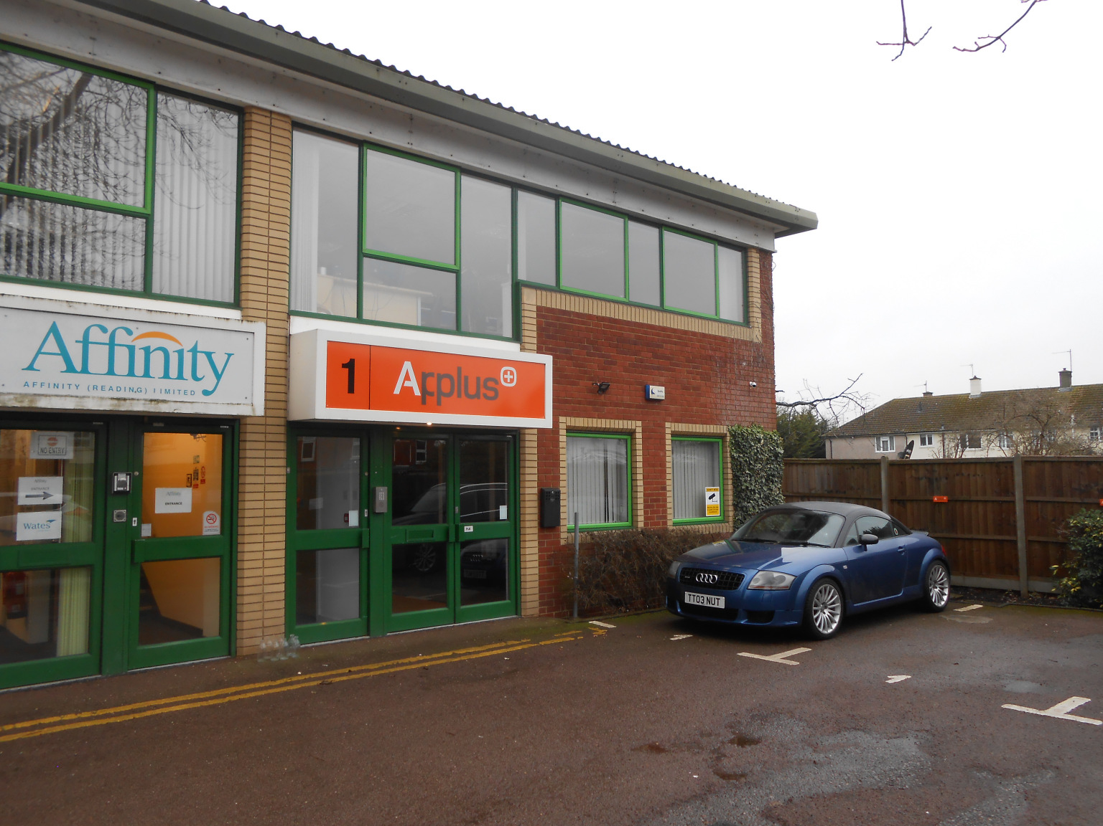

1 WOODSIDE BUSINESS PARK
WHITLEY WOOD LANE
READING RG2 8LW

LOCATION
The property is conveniently located 2 minutes drive of Jct. 11 of the M4 Motorway but close to excellent shopping facilities with a Lidl and Morrisons supermarkets and B&Q DIY store within a short drive.

DESCRIPTION
The property is an end of terrace unit with part brick, part glazed elevation under a metal clad roof. The building benefits from a good quality fit-out which comprises suspended ceiling with recessed lighting, carpeting and a mixture of ceiling and wallmounted air-conditioning cassette units.
On the ground floor there is a mixture of individual offices and the first floor is predominantly open-plan with 1 large meeting room. The unit benefits from a kitchen area and male & female WCs.
Externally there are 5 demised parking spaces immediately to the front of the building and a further 3 in the communal car park nearby.

ACCOMMODATION (NIA)
Ground Floor 980 sq ft
First floor 965 sq ft
Total 1,945 sq ft (180.6 sq m)

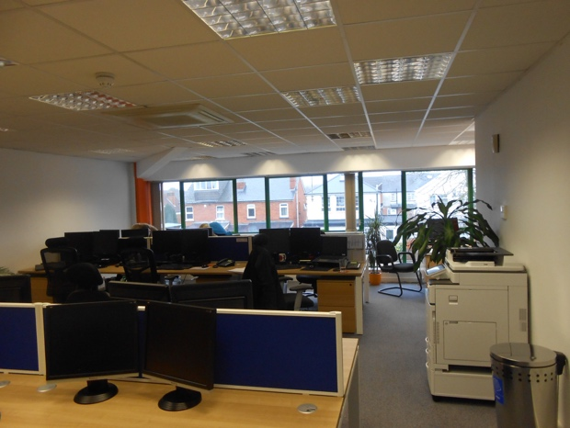

AMENITIES
- A mixture of open-plan
and individual offices
- Suspended ceilings
- Category 2 lighting
- Carpeting
- Male & female wc’s
- 8 car parking spaces
(ability to park additional cars)

TERMS
The property is available on a freehold basis at offers in the region of £350,000.

VAT
All prices quoted are exclusive
of VAT where applicable.

SERVICE CHARGE
There is a service charge payable
to cover the maintenance of the
common parts and roadways.

RATES
Rateable Value £25,500 as obtained
from the VOA Website. Current rate
in the £ is 49.3p.

LEGAL COSTS
Each party is to bear their own
legal costs in this matter.

VIEWING
Strictly by appointment through
the sole agent Walters Commercial
Shaun Walters
M: 07764 230561
E: swalters@walterscommercial.co.uk

