# OFFICES TO LET

# FIRST AND SECOND FLOOR

# ABOVE BE AT ONE

# APPROXIMATELY 1,926 SQ FT (178.9 SQ M)

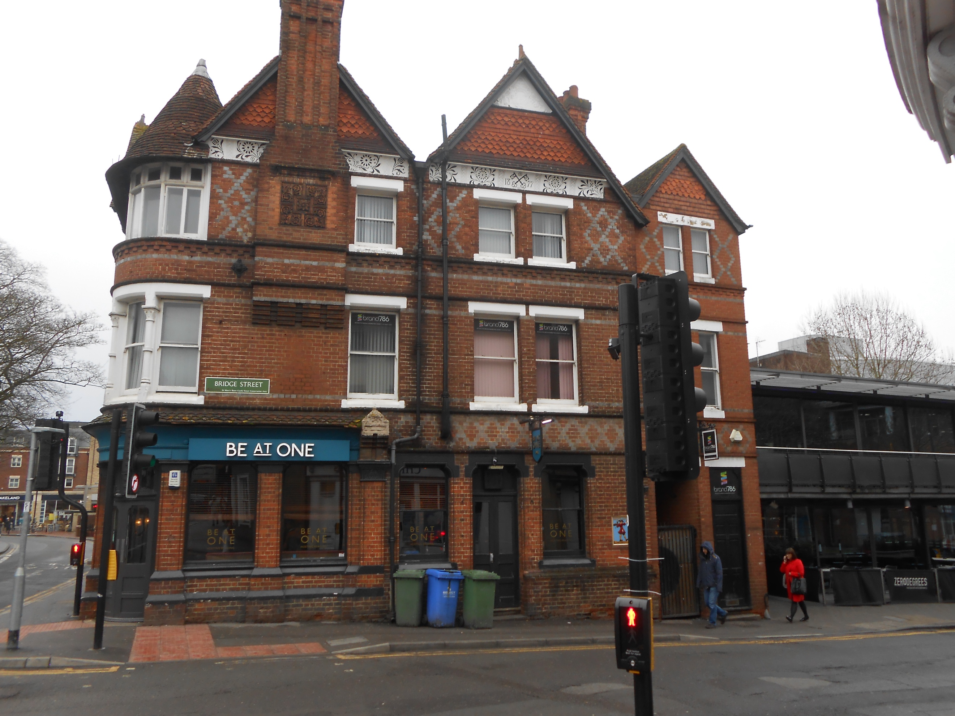

**1 GUN STREET  
READING RG1 2JR**

## DESCRIPTION

The property comprises a self-contained first and second floor office suite which provides a number of individual rooms which vary in size on both floors.

The suite is accessed via a single door from Bridge Street.

## LOCATION

The property is situated in a well established part of Reading occupying a prominent position on the corner of Gun and Bridge Street within close proximity to the Oracle Shopping Centre, John Lewis and a short walk to the pedestrianised Broad Street and mainline Station. Reading is a major commercial and administrative centre for the prosperous Thames Valley. Commercial links are excellent with junctions 10,11 and 12 M4 motorway all close by and regular rail services to London Paddington and Waterloo.

## ACCOMMODATION

First floor 875 sq ft 81.3 sq m

Second floor 1,051 sq ft 97.6 sq m

**Total 1,926 sq ft 178.9 sq m**

## LEASE

The property is available on a new internal repairing lease for a term to be agreed.

## RENT

£12 per sq ft

## SERVICE CHARGE

A service charge will be payable to cover the exterior maintenance.

## RATES

The rateable value for the first and second floor is yet to be separately assessed.

## VAT

All prices are exclusive of VAT where applicable.

## LEGAL COSTS

All parties are to bear their own legal costs in this matter.

## VIEWING

Strictly by appointment through   
the sole agent Walters Commercial  
**Shaun Walters**   
M: 07764 230561   
E: swalters@walterscommercial.co.uk